1. RF block diagram
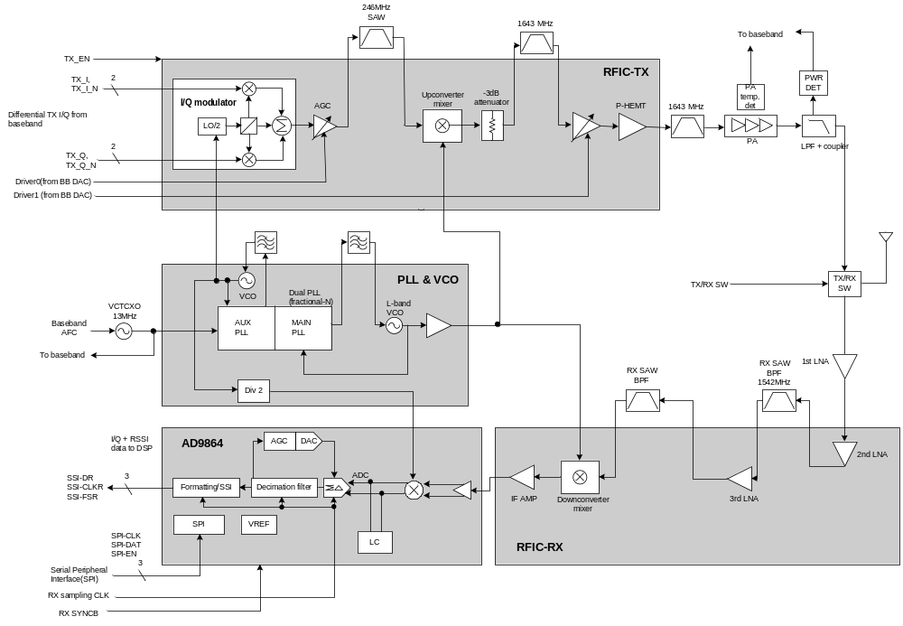
2. Receiver

1) 1st LNA: GaAs E-PHEMT used. Noise blocking from the transmitter and power supply circuitry
2) 2nd LNA: Si BJT used
3) 3rd LNA:
- Gain (@1542MHz): 15.9dB
- IIP3 (@1542MHz): +0.9dBm
- NF (@1542MHz): 1.29dB
4) RX down conversion mixer:
- Conversion gain: 10.7 dB
- NF: 9.5 dB
- IIP3: -2.1 dBm
5) Analog Devices’ AD9864 (IF digitizing subsystem)
- LNA
- Sigma-Delta ADC
- decimation filter
- post-sampling process
6) Receiver G/T and derived NF: -24 dB/K, 2.63 dB
7) Receiver selectivity interference conditions
case | Interference relative to sensitivity | Interference frequency offset
1 | +15dB | 31.25kHz
2 | +25dB | 93.75kHz
3 | +45dB | >500kHz

8) Receiver LO phase noise requirements

Frequency offset(kHz) | Expected RF phase noise | Expected IF phase noise
31.25 | -86.6 dBc/Hz | -83.6 dBc/Hz
93.75 | -96.6 dBc/Hz | -93.6 dBc/Hz
>500 | -116.6 dBc/Hz | -113.6 dBc/Hz

9) To ensure 6dB of SNR, IM3=-40dB, IIP3=-46dBm are needed
10) in-band blocking: -70dBm

3. Transmitter

1) TX-I/Q-Modulator: Differential in-phase and quadrature signals(I+, I-, Q+, Q-) from the baseband are inputted. After low pass filter the signals are up-converted to 246MHz, and then pass a variable gain stage.
Divide-by-2 circuit is needed to convert 492MHz of IF LO to 246MHz.
Modulator power supply is controlled by TX_EN from baseband.
2) TX up-converter: 246 MHz → 1626.5 ~ 1660.5 MHz
- conversion gain: around 10dB
- clock input from RF LO (1380.5 ~ 1414.5 MHz)
3) TX driver Amp.: control voltage is 0.5 ~ 2.5V
- Maximum power at 1.65V. Gain is 12 ~ 16dB.
- power supply is controlled by TX_EN from baseband.

4. Frequency Synthesizers

1) 13 MHz VCTCXO is reference clock. It is controlled by AFC of baseband.
2) Phillips SA8028 dual synthesizer is used. RF PLL is sigma-delta fractional-N, and IF PLL is integer-N.
3) IF VCO: stable performance 492MHz is fed to transmitter and receiver.
4) L-band VCO: single loop filter. Output of VCO passes dual buffer/amp. One is fed back to dual PLL and the other is fed to transmitter/receiver’s converter through Wilkinson driver.

